Week beginning:  Key Dates | 07/09 | 14/09 | 21/09 | 28/09 | 05/10  Harvest Festival- 05/10 | 12/10 | 19/10
Possible school visits/Enhancements | Tour of the school | Baby photos- parents to add to Tapestry | Photos of families- parents to add to Tapestry |  |  | Photos or visits of people that carry out jobs in our local area | Local walk or photos of the local area
Parent Partnership |  |  |  |  |  |  | Family Fun Time
Week | Week 1 | Week 2 | Week 3 | Week 4 | Week 5 | Week 6 | Week 7
Theme | Welcome | Me | My body | My family | My Friends | When I Grow up | My Locality
Focus Text | 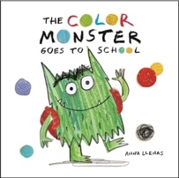  The Colour Monster Goes to School  (Anna Llenas) | 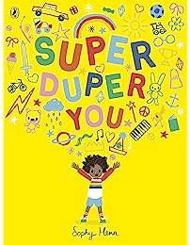  Super-duper you (Sophy Hen) | 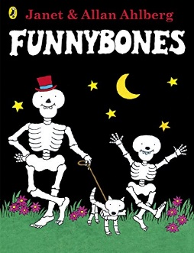  Funny Bones  (Janet and Allan Ahlberg) | 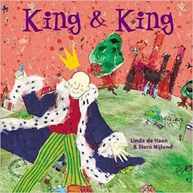  King and King (  Linda De Haan) | 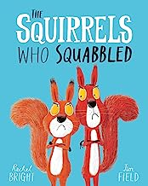  The Squirrels Who Squabbled (Rachel Bright) | 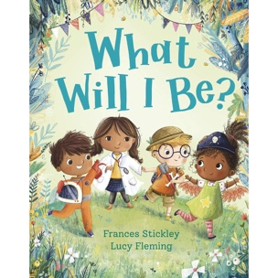  What will I be?  (Frances Stickley) | 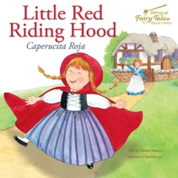  Little Red Riding Hood
Vocabulary | Feeling  Emotion  Happy  Sad  Angry  Scared  Excited  Worried | Unique  Fingerprint  Like  Dislike  Special  Past  Present | Body  Healthy  Unhealthy  Grow  Hydrate  Exercise  Change  Different  Same | Family  Relative  Sibling  Mother  Father  Brother  Sister  Grandparent | Special  Friend  Kind  Share  Thoughtful  Like  Dislike | Grow  Change  Job  Goal  Choice | House  Flat  Map  Country  Safety  Same  Different  Local  Touch/feel  Hear  See  Taste  Smell  Hot  Cold  Weather  Wind  Sun
Communication and Language  Speaking  Listening, Attention and Understanding | LTP: To show interest in new vocabulary, including words and phrases they may not have heard at home  LO: I can locate places around the school, using the correct vocabulary.  Activity: Tour of school discussing where things are and visiting places the children will need to be familiar with.  Questions: How do we get to the hall? Where are the toilets? What do you do if you can’t find ...? Where is the playground? Where do we line up? | LTP: To answer simple ‘where’, ‘who’ and ‘what’ questions  LO: I am learning to articulate my ideas and thoughts in well-formed sentences.  Activity: Make time to get to know the child and their families. Talk about their interests.  Questions: What do you love to play at home? Who do you like to play with? What makes you really happy? What are you really good at? What language do you speak at home? | LTP: To expand and use new context specific vocabulary, including from school life.  LO: I am learning to explain how things work and why they might happen.  Activity: Draw round a child and label the key body parts. Then discuss what functions each body part has and why.  Questions: What is this part? What does it do? What would someone do if they didn’t have this? | LTP: To answer simple ‘where’, ‘who’ and ‘what’ questions  LO: I am learning to discuss who is important to me.  Activity: Discuss who lives in our homes including family pets. Could make links to greetings from different cultures?  Questions: Who lives in your house with you? Do you have any brothers or sisters? Do you have any pets in your family? Where do you live? Is there someone really special to you? Does your family have any special celebrations? What language(s) do people speak in your family? | LTP: To expand and use new context specific vocabulary, including from school life.  LO: I am learning to articulate my ideas and thoughts in well-formed sentences.  Activity: Talk about what they enjoy/who they like playing with and why. Say something kind/ about what you admire about someone in the room.  Questions:  What is your favourite thing to play at school? Do you like playing on your own or with others? Who do you like to play with? What makes them a good friend? Can you say something kind about someone in this room? | LTP: To increase confidence when using the future tense in talk.  LO: I am learning to articulate my ideas and thoughts in well-formed sentences.  Activity: Children to talk about what they want to do when they grow up and what they must do to achieve that goal.  Questions: What would you like to be when you grow up? Why do you want to do that job? What do you think that job is like? Have you seen anyone do that job before? What do you think you need to learn to do that job? What are you already good at that will help you? What could you do now to help you learn more? Who could help you learn what you need? | LO: I am learning rhymes and songs.  Activity: Perform the song ‘Lots of Room's’ to the tune of ‘Head, Shoulders, Knees and Toes’.  Questions: What parts of the song do you remember best? What actions did you do during the song? Which move was your favourite? Did you notice any rhyming words? How did singing the song make you feel?
PSED  Managing self  Building relationships |  | Jigsaw -  LO: I understand how it feels to belong and that we are similar and different  Activity:  Empty a brightly covered box holding an assortment of toys from the classroom onto the floor. Include a range of toys such as puzzles, construction, role-play, small world etc.  Give children an opportunity to look at and talk about the toys they like and why.  Explore whether they have ever played with these toys before. Explain that these toys belong to the classroom, just like all of you do! We share them, look after them, and make sure they’re ready for everyone to use.  Ask the children to think about toys that they play with at home too.  Invite the children to share their ideas:  “I like… because…”  Tour with Jerrie cat to reinforce tidying expectations. | Jigsaw -  LO: I can start to recognise and manage my feelings  Activity:  Look at the photos showing four emotions. Happy, sad, angry, and excited.  Question: Why might these children be feeling happy / sad / excited / angry, etc?  Introduce Jigsaw Jenie and the learning charter. | Jigsaw -  LO:  I can work together with others and consider other people’s feelings  Activity: Model a role-play scenario with Jigsaw Jenie and Jerrie Cat.  Jigsaw Jenie is playing with the play dough. Jigsaw Jenie has the rolling pin, but Jerrie Cat really wants to have a turn. Jerrie has been waiting for ages and ages, but Jigsaw Jenie is still using it. Jerrie Cat feels like he is going to cry.  Questions: How might Jerrie Cat be feeling? What could Jerrie Cat do? | Jigsaw -  LO: I understand why it is good to be kind and use gentle hands  Activity: Look at the images of different ways to use our hands.  What are the children’s hands being used for in the pictures?  Explain that we can make choices to be kind to other people.  Questions: What should we try not to use our hands for? Why not?  Explain that we can tell somebody we don’t like something by showing our hand and politely saying ‘Please stop, I don’t like it”. Explain to the class that if anyone ever says that to them, they should stop immediately. | Jigsaw -  LO: I am starting to understand children’s rights and this means we should all be allowed to learn and play  Activity: Look at and share your school rules/values. Why do we have them?  What happens if we don’t keep the rules – how does it affect others?  Explain that we have a right to learn and play. We have a right to be happy when we come to school.  Ask the children to think about how they are feeling at school today. Emphasise our right to be happy at school and what we do to support others feel happy too.  Sing ‘if you’re happy and you know it… give a smile, help a friend, share a toy etc. | Jigsaw -  LO: I am learning about what responsible means  Activity: Show the children Jigsaw Jenie’s cress pot. Explain that Jigsaw Jenie has been trying really hard to take care of it. It first started as a seed and now it is really tall.  Jigsaw Jenie made a choice to be responsible. Being responsible means that we try our best to look after something.  Question: I wonder how Jigsaw Jenie made the cress grow?  Ask the children to think about how they could make responsible choices.  What could they do at school or at home to be responsible?  Is there a job or task that they would like to be responsible for?
Physical Development  Fine Motor  Gross Motor | Fine –  LTP: To use smaller objects and implements in play with increasing accuracy and for the intended purpose.  LO: I am learning to develop my fine motor skills  Activity: Children to place sticky dots over the letters in their name  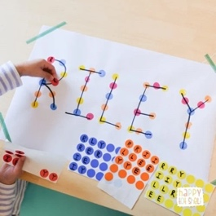  Questions: What is your name? How many sounds/letters are in your name? What letter does it start with? Is this letter in your name?  Gross –  LTP: To show strength, balance and coordination in movement.  LO: To move safely and sensibly in a space with consideration of others  Activity: To share equipment with others. To choose my own method of travelling.  Questions: How do you keep your balance when moving low/ high and in different directions?  What do you do if someone is in front of you? Can you show me how you stop safely? How does your body feel after running? | Fine –  LTP: I am learning to develop my fine motor skills so that I can use. range of tools competently, safely and confidently.  LO: I am learning to develop my fine motor skills  Activity: Children thread the letters of their name onto a string or pipe cleaner.  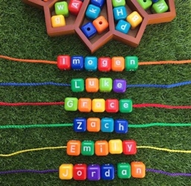  Questions: What is your name? How many sounds/letters are in your name? What letter does it start with? Is this letter in your name?  Gross –  LTP: To move around, under, over, and through different objects and equipment. Begin to move with control and care.  LO: To develop moving safely and stopping with control.  Activity: Children to complete an obstacle course/ exercise circuit.  Questions: How will you move under/ over? Can you change direction? Can you move in a different way? | Fine –  LTP: I am learning to develop my fine motor skills so that I can use. range of tools competently, safely and confidently.  LO: I am learning to develop my fine motor skills  Activity: Children to push split pins through bones to make a skeleton.  Questions:  How will you join the…? What body parts will be connected to the legs?  Gross –  LTP: To show strength, balance and coordination in movement.  LO: To use equipment safely and responsibly.  I am learning to listen carefully to instructions and put down equipment down safely and freeze.  Activity: Children to stand in their own space with a beanbag, look for space to move in to and change direction. Move beanbag from one hand to another.  Questions: How can we move safely around others? Can you throw beanbag up and catch in place? | Fine –  LTP: To use smaller objects and implements in play with increasing accuracy and for the intended purpose.  LO: I am learning to develop my fine motor skills  Activity: Children to decorate a crown for a King (tweezers to pick up decorations).  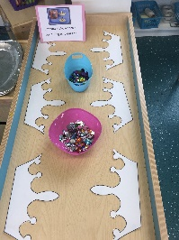  Questions: How would you put them on? Can you make a pattern? What will you use to create them? What shapes will you use to colour/ add to them?  Gross –  LTP: To use different ways of moving and travelling  LO: To use different travelling actions whilst following a path.  Activity: Children to play a follow me game.  Questions: Can you hop on one leg? What leg can you hop better on? What number have you landed on? Can you throw the stone/ pebble gently? | Fine –  LTP: To use smaller objects and implements in play with increasing accuracy and for the intended purpose.  LO: I am learning to develop my fine motor skills  Activity: Children to make a friendship bracelet threading beads or pasta onto string or wool.  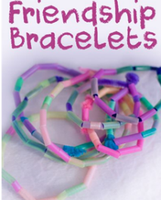  Questions: Who did you make the bracelet for? How did you make it / create the pattern? What materials did you/ will you use? What was easy/ hard?  Gross –  LTP: To start to make gross movements to music independently and dance along to music and begin to link movements with control  LO: To work with others co-operatively and play as a group.  Activity: Children to play parachute games  Questions: Can we make big waves? Can you make big movements? Can you make small movements? Can you travel in different ways? | Fine –  LTP: To manipulate a range of tools and equipment in one hand  LO: I am learning to develop my fine motor skills  Activity: Children to use laces to thread around the people who help us cut-outs.  Questions: What person have you picked? How are you going to start the threading? Can you weave in and out?  Gross –  LTP: To show strength, balance and coordination in movement.  LO: To follow, copy and lead a partner.  Activity: Children to play a follow the leader game.  Questions: How do you keep your partner safe? Which jumps and movements did you do with your partner? How did you decide where to move? | Fine -  LTP: I am learning to develop my fine motor skills so that I can use. range of tools competently, safely and confidently.  LO: I am learning to develop my fine motor skills.  Activity: Children to use weaving skills to make Little Red Riding Hood a basket.  Questions: How did you weave the paper? Can you describe the pattern you have made? What colours have you used?  Gross -  LTP: To use different ways of moving and travelling  LO: To consolidate skills learnt including travelling actions following a partner.  Activity: Use movement and travelling skills learnt to follow leader safely, add and develop last weeks skills.  Questions: How will you travel? Why did you choose to travel this way? Did you keep your partner safe in the space? Which route did you take?
Understanding the world  Past and present  People, culture and communities  The natural world | LTP: To follow and create simple maps of familiar places.  LO: I am learning to draw information from a simple map.  Activity: Look at a bird's eye view of the classroom introducing and using new vocabulary where appropriate.  Questions: What do you think this picture is showing? Why do you think it’s called a bird’s eye view? Can you find where the carpet area is? Where do you think the door is? | LTP - To comment on images of familiar situations in the past. To describe life events in sequence.  LO: I am learning to comment on images from the past.  Activity: Get the children to bring in a baby photo of themselves and share it with the class explaining similarities and differences.  Questions:  What can you do now that you couldn’t when you were a baby?  Can you match the baby pictures to the correct person? | LTP: To observe the change in plants and trees across the different seasons  LO: I am learning to understand seasonal change.  Activity: Visit a woodland area- discuss why leaves and other items are on the floor/ beginning to fall on the floor of the woods.  Use these items to make a nature skeleton.  Questions:  What do you see on the trees in autumn?  What happens to the leaves? What colours can you see on the ground? Is it warmer or colder than summer? What do we wear when it’s autumn? What do animals do in autumn? Can you name an animal that collects food in autumn? | LO: I am learning to talk about members of my immediate family.  Activity: Share pictures of family and listen to what children say. Show how there are many different families. Give children the opportunity to ask questions about your family.  Questions: Who is in your picture?  What do you like to do with your family? Where was this picture taken? Do our families all look the same? What is the same about our families? What is different? Is it okay if families have one grown-up, two grown-ups, or lots of people? What do all families have in common? (e.g. love, care, fun) | LO: I am learning to describe people who are familiar to me.  Activity: Children to pick someone in the class to describe. One child at a time describes their friend to the rest of the class for them to guess who they are talking about.  Questions: What do they look like? What are they like? What do they like to do? Why do you like being their friend? | LO: I am learning to discuss members of my immediate family and community.  Activity: Meet people from different occupations (arrange invites)  Children to prepare questions to ask.  Questions:  What do you want to know about their uniform? What would you like to ask about their tools? What do you wonder about their day? Can you think of a question that starts with "How" or "Why"? | LTP: To follow and create simple maps of familiar places.  LO: I am learning to draw information from a simple map.  Activity: Children to become familiar with the roads that are close to our school. Children to have the opportunity draw a simple map of our school/ our local area/ Little Red Riding Hood’s journey.  Questions: What places did you put on your map? Can you show me where the school is? What’s the closest place to the school on your map? If I wanted to walk from the playground to the park, how would I get there?
Computing |  | LTP: To handle devices with care  LO: To share different types of technology within the classroom and how we care for it/handle it.  Activity: Talk and model looking after equipment and expectations and boundaries around using specific technology. | LTP: To understand how to operate a familiar device  LO: Explore a device each week, teach the children how to handle/care for it but also how to operate it and close it down when finished. | LTP: To use technology in a healthy way  LO: I am learning to understand how much time I should spend using technology  Activity: Agree what is technology, Discuss and sort which types of technology are used at home. | LTP: To use technology in a healthy way  LO: I am learning to understand how to use technology in a healthy way  Activity: Explore known/safe apps as well as browsing. Not navigating away for specific pages.
Expressive arts and design  Creating with materials  Being imaginative and expressive | LTP: To sustain concentration and control when using simple tools and techniques competently and appropriately.  LO: I am learning to create something collaboratively  Activity: Children to collaboratively paint the large colour monster cut out.  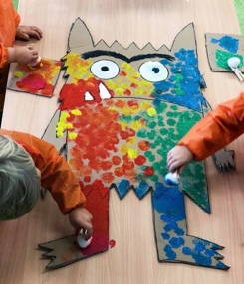  Questions: What colour does ... represent?  How would they be feeling if they were ...? | LTP: To experiment and create different textures.  LO: I am learning to explore a variety of different effects.  Activity: Children to create self-portraits (link to Van-Gogh).  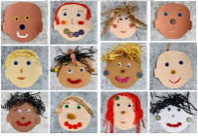  Questions: How will you make your eyes/ nose/ mouth?  What colour is your hair/ eyes? Where is your ...? What colour is/are your ...? How many ... do you have? | LTP: To experiment and create different textures.  LO: I am learning to explore a variety of different effects.  Activity: Making a skeleton using paper straws/ cotton wool buds, stick them to black paper.  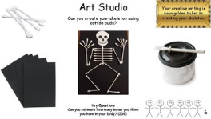  Learn the funny bones song (Twinkl).  Questions:  How do our bodies look? How many arms do we have? How many legs? Which bone is connected to ...? | LTP: To manipulate materials to achieve a planned effect  LO: I am learning to join materials.  Activity: Children to create a family portrait of who they live with.  Connect lolly sticks with glue to make a house shape.  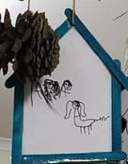  Questions: What shape is your house? What shape is the roof? Do you have a chimney? | LTP: To experiment and create different textures.  LO: I am learning to explore a variety of different effects.  Activity: Children to create fruit face portrait of a friend (link to Guiseppe Arcimbaldo). Print black and white photos of class so that children can cut and stick fruit for each feature.  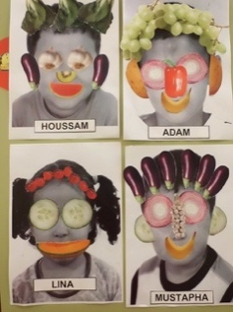  Questions: What features can you see on your face? What fruit will you use for each feature and why? What shapes will you need? What would be a good item of fruit for a mouth? | LTP: I am learning to copy and continue repeating patterns  LO: I am learning to explore a variety of different effects.  Activity: Use shapes. Fruit or vegetable printing to make a repeating pattern  Questions: What fruit/veg will you use? What comes first? What will come next? How do you know? How will you print the shape on the paper? | LTP: I am learning to plan to construct with a purpose in mind  LO: I am learning to join materials.  Activity: Use junk modelling and other craft materials to make Grandma’s house.  Questions: What materials have you used? How have you joined the materials? What else could you use to join? What has worked well? What could you do to make it even better?  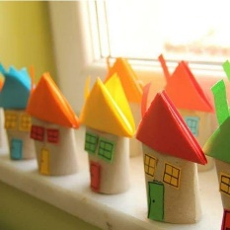
Climate Curriculum | Know that we can use our five senses to explore and celebrate different colours, textures and smells in nature (CC)
Climate Curriculum | Below are climate curriculum statements that are ongoing and can lend themselves to learning in the EYFS generally please highlight the learning statements as you cover them.  Sing songs, play games, have circle time regularly in green spaces.  Comment on day-to-day weather patterns.  Know the extreme seasons (summer and winter) and can comment on the common weather patterns.  Know which clothes to wear for each weather type.  Be exposed to stories around the world, in which people are taking positive action together.  Take part in activities that promote positive human change (walk to school days, no electricity days)  Begin to understand that the future will be different depending on what we do now. Pupils are exposed to positive stories of environmental advocates at an age-appropriate level.  Participate in circle time to discuss viewpoint on nature and share opinions.  Develop a positive relationship with nature.  Children can ‘think scientifically’ and carry out and watch small science experiments in groups / with peers.  Explore tree anatomy through activities such as nature bingo, bark rubbing, nature art.  Children are given opportunities to spend time outdoors in nature and share how they feel when interacting with nature.

