Pupils with Medical Conditions and Administration of
Medicines policy

Audience: | Parents  Academy Staff and Volunteers  Local Governing Bodies  Trustees  Local Authorities
Ratified: | REAch2 Trust Board  July 2025
Other related policies: | First Aid  Health & Safety  Inclusion/SEND
Policy owner: | Helen Beattie, Head of Safeguarding
Review: | Every three years

At REAch2, our actions and our intentions as school leaders are guided by our Touchstones.



Contents

1. Aims 4
2. Legislation and statutory responsibilities 4
3. Roles and responsibilities 4
Administration of medicines 7
Policy review 9
Appendix 1 – parent agreement to administer medicines in the school setting 10
Appendix 2 – Record of medicines administered 11
Appendix 3 – General care plan 12
Appendix 4 – Asthma care plan (from Asthma.org.uk) 16
Appendix 5 – Anaphylaxis care plan requiring Epi Pen (from BSACI.org, see website for other templates) 17

1. Aims

This policy aims to ensure that:

- Pupils, staff and parents understand how our school will support pupils with medical conditions
- Pupils, staff and parents understand how our school will support pupils with administration of any medicines
- Pupils with medical conditions and requirements for administration of any medicines are properly supported to allow them to access the same education as other pupils, including school trips
- The safety and welfare of pupils, including their physical and mental wellbeing, is promoted at all times
- A culture of safety, equality and protection is promoted

We will ensure implementation of this policy by:

- Making sure sufficient staff are suitably trained
- Making staff aware of a pupil’s condition, where appropriate
- Making sure there are cover arrangements to ensure someone is always available to support pupils with medical conditions and administration of medicines
- Developing and monitoring healthcare plans
- Developing individual Personal Emergency Evacuation Plans (PEEPs)

The named person with responsibility for implementing this policy is name, role

2. Legislation and statutory responsibilities

This policy meets the requirements under Section 100 of the Children and Families Act 2014, which places a duty on governing boards to make arrangements for supporting pupils at their school with medical conditions.
It is based on the requirements outlined in the Department for Education’s statutory guidance ‘Supporting pupils at school with medical conditions’, and is intended to be in accord with all other statutory/guidance documents referenced therein. Please see the statutory guidance itself for further information. This policy is also in adherence to requirements for Early Years pupils, as per the Department for Education’s statutory guidance ‘Early years foundation stage statutory framework for group and school based providers’.

For the purposes of this policy, ‘parents’ refers to any individual who holds parental responsibility for the child in question.

3. Roles and responsibilities

3.1 The governing body

The governing body has delegated responsibility to make arrangements to support pupils with medical conditions, which includes the administration of medicines. The governing body will ensure that sufficient staff have received suitable training and are competent before they are responsible for supporting children with medical conditions and/or administration of medicines.

3.2 Key roles

The Headteacher will:

- Make sure all staff are aware of this policy and understand their role in its implementation
- Ensure that there is a sufficient number of trained staff available to implement this policy and deliver against all healthcare plans and requirements for administration of medicines, including in contingency and emergency situations
- Take overall responsibility for the development of healthcare plans
- Ensure that liaison takes place with named healthcare professionals in the case of any pupil who has a medical condition that may require support at school
- Ensure that effective systems are in place for obtaining information about a child’s medical needs and any needs for administration of medicines, and that this information is kept up to date

Use this section to add any further detail about specific roles and responsibilities for other key staff involved in the operation of this policy, i.e. SENCO, office co-ordinator, etc.

3.3 Staff

Supporting pupils with medical conditions during school hours is not the sole responsibility of one person. Any member of staff may be asked to provide support to pupils with medical conditions, although they will not be required to do so. This includes the administration of medicines. Those staff who take on the responsibility to support pupils with medical conditions and/or administration of medicines will receive sufficient and suitable training, including modules offered by Flick (REAch2’s online learning platform) and additional training resources provided by the Shared Services team. Staff will be required to achieve the necessary level of competence before administering medicines, and are covered by the Academy's liability insurance, a copy of which is available on request. Teachers will take into account the needs of pupils with medical conditions that they teach. All staff will know what to do and respond accordingly when they become aware that a pupil with a medical condition needs help.

3.4 Parents

Parents will:

- Provide the school with sufficient and up-to-date information about their child’s medical needs, including required information about administration of medicines
- Be involved in the development and review of their child’s healthcare plan
- Carry out any action they have agreed to as part of the implementation of the healthcare plan
- Submit a completed permission form prior to before bringing medicine into school
- Provide the school with the medicine their child requires
- Notify the school if their child’s medical condition and/or medicine changes or is discontinued, or any changes in the dose or administration method
- Ensure they, or another nominated adult, are contactable at all times in case of medical emergencies. N.B. we request that there are two or more emergency contact phone numbers for all pupils

3.5 Pupils

Pupils with medical conditions will often be best placed to provide information about how their condition affects them. Pupils should be fully involved in discussions about their medical support needs and contribute as much as possible to the development of their healthcare plan. They are also expected to comply with their healthcare plan.

4. Equal opportunities

We understand our responsibility to actively support pupils with medical conditions to participate in school activities, including trips and visits, and not prevent them from doing so. The school will consider what reasonable adjustments need to be made to enable these pupils to participate fully and safely. Risk assessments for any activity will be carried out so that planning arrangements take account of any steps needed to ensure that pupils with medical conditions are included, which will include any need for administration of medicines. In doing so, pupils, their parents and any relevant healthcare professionals will be consulted.

5. Being notified that a child has a medical condition

Parents are expected to notify the school as soon as they are aware of a new medical condition, or any changes to an existing medical condition, for their child. When notified of this, the process outlined below will be followed to decide whether the pupil requires a healthcare plan. The school will make every effort to ensure that arrangements are put into place within two weeks, or by the beginning of the relevant term for pupils who are new to our school.

6. Healthcare plans

The Headteacher has overall responsibility for the development of healthcare plans for pupils with medical conditions. Operational oversight of these tasks has been delegated to name of individual/role.

Not all pupils with a medical condition will require a healthcare plan. It will be agreed with a healthcare professional and/or parents when a healthcare plan would be inappropriate or disproportionate. This will be based on evidence.

Healthcare plans will be developed with the pupil’s best interests in mind and will set out what needs to be done, when and by whom. They will be drawn up in partnership with the school, parents and a relevant healthcare professional, such as the school nurse, specialist or paediatrician, who can best advise on the pupil’s specific needs. The pupil will be involved wherever appropriate. The healthcare plan will be linked to, or become part of, any education, health and care (EHC) plan. If a pupil has SEN but does not have an EHC plan, the SEN will be mentioned in the healthcare plan as required. The final agreement of a parent will be sought before implementation.

The level of detail in the healthcare plan will depend on the complexity of the child’s condition and how much support is needed. The following factors as a minimum will be considered when deciding what information to record:

- The medical condition, its triggers, signs, symptoms and treatments
- The pupil’s resulting needs, including medicine (dose, side effects and storage) and other treatments, time, facilities, equipment, testing, access to food and drink where this is used to manage their condition, dietary requirements and environmental issues, e.g. crowded corridors, travel time between lessons
- Specific support for the pupil’s educational, social and emotional needs; for example, how absences will be managed, requirements for extra time to complete exams, use of rest periods or additional support in catching up with lessons, counselling sessions
- The level of support needed, including in emergencies. N.B. if a pupil is self-administering any medicines, this will be clearly stated with appropriate arrangements for monitoring
- Who will provide this support, their training needs, expectations of their role and confirmation of proficiency to provide support for the pupil’s medical condition from a healthcare professional, and cover arrangements for when they are unavailable
- Who in the school needs to be aware of the pupil’s condition and the support required
- Arrangements for written permission from parents for any medicines to be administered by a member of staff, or self-administered by the pupil during school hours
- Separate arrangements or procedures required for school trips or other school activities outside of the normal school timetable that will ensure the pupil can participate, e.g. risk assessments
- Where confidentiality issues are raised by the parent/pupil, the designated individuals to be entrusted with information about the pupil’s condition
- What to do in an emergency, including who to contact, and contingency arrangements

Please see the appendices to this policy for healthcare plans, templates for general conditions, and for asthma and anaphylaxis specifically, which are recommended for use. Plans will be reviewed at least annually, or earlier if there is evidence that the pupil’s needs have changed. They will be stored confidentially, but within easy access of relevant staff.

Administration of medicines

If administration of medicines is required during the school day, parents are requested to inform the school as soon as possible. Upon advice of the British Medical Association, both prescribed and non-prescribed medicines, i.e. for hayfever, can be administered at school. In the case of prescribed medicines, parents will be required to provide evidence from the child’s GP. Evidence of any required change to prescribed medicines must be provided to the school immediately to ensure immediate implementation, which will be clearly recorded by school staff to ensure the change is effectively communicated. This may require supplying newly labelled prescriptions or items in line with such changes. In the case of non-prescribed medicines, parents will be required to share the reasoning for the administration of the medicines and the anticipated timescale for this prior to the school giving agreement to do so. Where possible, we request that medicines be administered at home by parents before or after school, unless otherwise stated by a medical professional. We have a small supply of Calpol and antihistamines that can be administered with parental permission. (amend as required, or delete if not applicable)

All staff authorised to administer medicines will follow administration procedures as advised by a healthcare professional and as agreed with the parents and child. Two members of staff will witness the administration of medicine. Where the medicine requires specialist technique or equipment, e.g. inhaler, the members of staff responsible for administration will be required to demonstrate competence before taking on this role, as assessed by the Headteacher and additionally by a healthcare professional if required. In the event of pain medicine needing to be administered as part of a care plan, or in the event of administration of non-prescription pain medicine, explicit consent will be needed from parents in order to check the most recent dosage and ensure administration is within safe guidelines. In this instance, contact will be made with parents to clarify the most recent dosage and to agree further administration of the pain medicine, if necessary. A written record of this discussion will be requested to be signed by parents at the end of the school day. Parents have the opportunity to come into school to administer any medicines should they wish to do so, or if this is deemed the most appropriate option for the child. If a child refuses to take medicines, staff will not force them to do so, but will note this in the records and inform parents immediately or as soon as is reasonably possible.

We may, in the event of a critical situation, administer medicine to a child without consent of a parent if the First Aider or medical services believe there is imminent life risk. Parents will be informed of this action as soon as is practically possible. We have a ‘spare’ asthma inhaler and auto adrenaline injector for administration to pupils in the event of an emergency, as directed by medical staff. (delete if not applicable)

Receipt, storage and disposal of medicines

We will compile a medicines list detailing information concerning all medicines for which we have permission to be administered within the school, including details of dose and frequency. It will also include the expiry date of each medicine, which will be monitored and kept under regular review to avoid administering expired medicines. The medicines list will be stored confidentially, but within easy access of relevant staff.

Insert information here about storage of medicines – where, who has access, is it locked, who has the key(s), where refrigerated medicines are stored, security/safeguarding arrangements to limit unauthorised access, etc

All medicines must be delivered to the school office by the parent in person, who will then be required to complete and sign a permission form (see appendix) Under no circumstances will medicines be left in a child’s possession, unless immediate emergency treatment is expected to be required, i.e. use of inhaler during sporting activity. We can only accept medicines in their original containers as dispensed by a healthcare professional, complete with original labels and/or accompanying written directions. We cannot accept medicines that have been taken out of their original container. Each item of medicine must be clearly labelled with the following information:

- Pupil’s name
- Name of medicine(s)
- Dosage
- Frequency and timing of administration
- Date of dispensing
- Storage requirements (if relevant)
- Expiry date

If relevant, parents are required to provide full details of any rescue therapy, including the dosage and frequency of administration, and any additional action to be taken if this is not effective.

It is the parent’s responsibility to ensure that all medicines are in date and suitable for use. The member of staff receiving the medicines will check the items against the information stated on the form, and place the items in the approved secure storage location, clearly named and labelled. Where a child is prescribed emergency medicines (e.g. inhaler, auto adrenaline injector) it will be securely stored in a location that is easily available if required in an emergency, including during any external activity or trip. Emergency medicines will be collected by staff in the event of any evacuation, i.e. fire drill, to ensure they remain accessible. If required, the temperature of the facility used to store any medicines, including a medicines fridge, will be recorded on a daily basis to ensure that the required temperature is maintained.

In the event of medicines needing to be transported to and from school on a daily basis, i.e. antibiotics, the parent is responsible for ensuring that both delivery and collection occurs.

The school is not responsible for disposing of medicines and in the event that medicines are out of date then parents will be requested to collect it. Parents are responsible for ensuring that expired or unwanted medicines are returned to the pharmacy for safe disposal. Parents must collect all unused medicines at the end of the agreed administration period. Should medicines be left at school beyond three months, despite attempts made to contact the parent to collect it, it will be given by the school to a pharmacy for safe disposal.

Documentation

Each occasion where medicines are administered will be recorded on an administration of medicines form (see appendix)/Arbor/Medical Tracker (amend/delete as applicable) This information is confidential to school staff and will be stored and retained securely in line with REAch2’s record retention policy.

Policy review

This policy will be reviewed every three years. Review will take place more regularly in the event of changes to statutory requirements, or in light of feedback arising from pupils, parents or staff involved with supporting pupils with medical conditions and/or administration of medicines.

Appendix 1 – parent agreement to administer medicines in the school setting

Name of school
Name of child
Date of birth
Class
Medical condition or illness
Name/type of medicine
(as described on the container)
Expiry date
Dosage, method, frequency and timing
Total amount given to school
Special precautions or other instructions
Are there any side effects that the school needs to know about?
Self-administration – yes or no?
Procedures to take in an emergency
Emergency contact name
Daytime telephone number
Relationship to child

The above information is, to the best of my knowledge, accurate at the time of writing and I give consent to school staff to administer the above medicine(s) in accordance with the school policy. I will inform the school immediately, in writing, if there is any change in dosage or frequency of the medicine, or if the medicine is stopped.

Name: Relationship to pupil:

Signature: Date:

Appendix 2 – Record of medicines administered

Name of school/setting |  |  |  | Child’s name:
Medicine: |  | Dose: |  | Time of day: |  | Method:

Date | Time given | Stock prior to administration | Dose given | Administered by  (Signature) | Checked by  (Signature) | Stock after administration

Appendix 3 – General care plan

Child’s Name: |  | Photo
Group/class/form: |  | Photo
Date of birth: |  | Photo
Child’s address: |  | Photo
Medical diagnosis/condition: |  | Photo
Date: |  | Photo
Review date (Year 1):
Review date (Year 2):

Parent / Carer Contact details
Parent/Carer 1:
Phone No. (Work):
Phone No. (Home):
Mobile No :
Relationship to child:
Parent/Carer 2:
Phone No. (Work):
Phone No. (Home):
Mobile No :
Relationship to child:

Clinic/Hospital Contact
Name:
Phone No:

G.P.
Name:
Phone No:

Who is responsible for providing support in school

Describe medical needs and give details of child’s symptoms, triggers, signs, treatments, facilities, equipment or devices, environmental issues etc.

Name of medication, dose, method of administration, when to be taken, side effects, contra-indications, administered by/self-administered with/without supervision

Daily care requirements

Specific support for the pupil’s educational, social and emotional needs

Arrangements for school visits/trips etc.

Other information

Describe what constitutes an emergency, and the action to take if this occurs

Who is responsible in an emergency (state if different for off-site activities)

Plan developed with

Staff training needed/undertaken – who, what, when

Health plan agreed by:
Name | Date | Relationship | Signature

Form copied to
 | Class | Year | Date

Appendix 4 – Asthma care plan (from https://www.asthmaandlung.org.uk/)

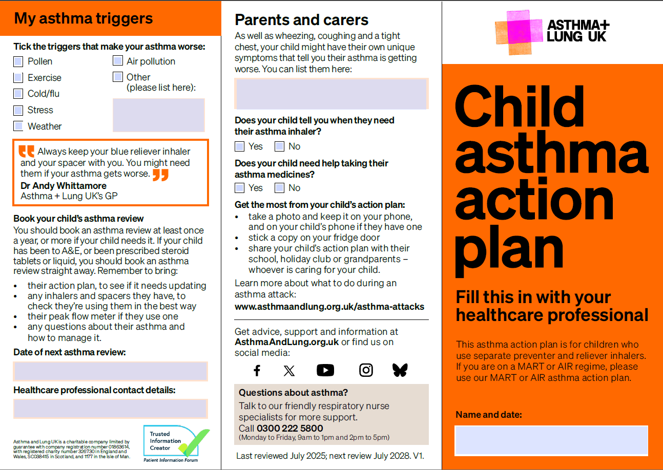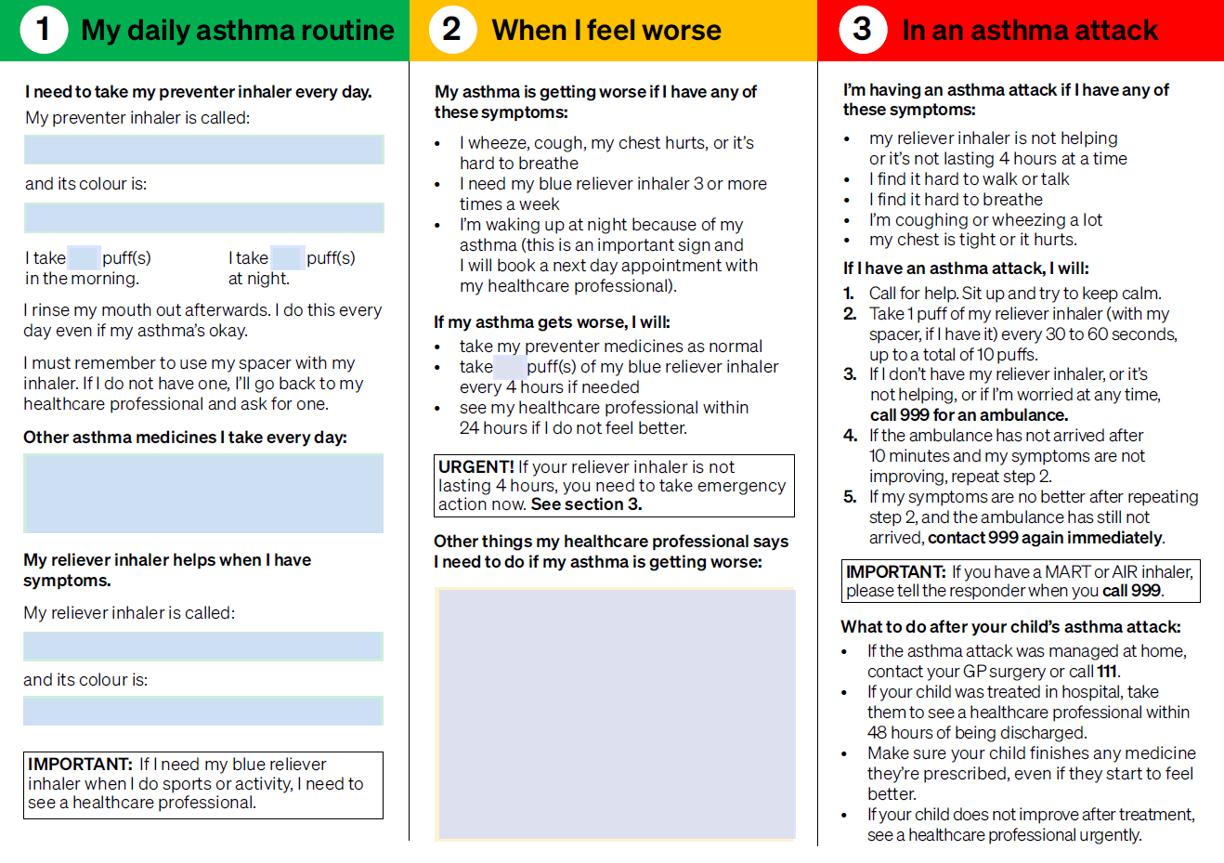

Appendix 5 – Anaphylaxis care plan requiring Epi Pen (from BSACI.org, see website for other templates)


