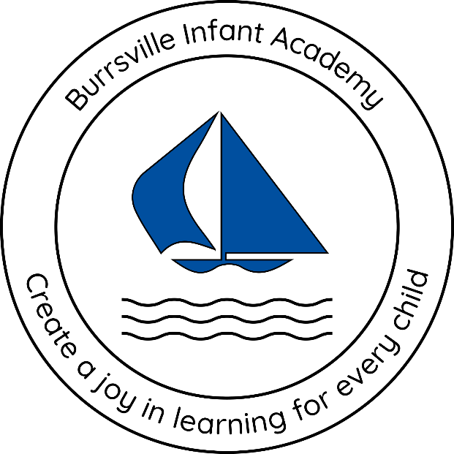

Burrsville Infant Academy

Accessibility Plan
2025-2026

Date last reviewed: |  | 13.10.2025
Signed by:
 | Headteacher |  | Date:
 | Chair of governors |  | Date:

Contents:
Statement of intent
- Legal framework
- Roles and responsibilities
- The Accessibility Audit
- Planning duty 1: Curriculum
- Planning duty 2: Physical environment
- Planning duty 3: Information
- Monitoring and review

Statement of intent
This plan outlines how Burrsville Infant Academy aims to increase access to education for pupils with disabilities in the three areas required by the planning duties in the Equality Act 2010 (i.e. the curriculum, physical environment and information).
A person is regarded as having a disability under the Equality Act where they have a physical or mental impairment that has a substantial and long-term adverse effect on their ability to carry out normal day-to-day activities.
This plan aims to:
- Increase the extent to which pupils with disabilities can participate in the curriculum.
- Improve the physical environment of the school to enable pupils with disabilities to take better advantage of education, benefits, facilities and services provided.
- Improve the availability of accessible information to pupils with disabilities.
The above aims will be delivered within a reasonable timeframe, and in ways which are determined after taking into account pupils’ disabilities and the views of parents and pupils. In the preparation of an accessibility strategy, the LA will have regard to the need to allocate adequate resources in the implementation of this strategy.
The governing board also recognises its responsibilities towards employees with disabilities and will:
- Monitor recruitment procedures to ensure that individuals with disabilities are provided with equal opportunities.
- Provide appropriate support and provision for employees with disabilities to ensure that they can carry out their work effectively without barriers.
- Undertake reasonable adjustments to enable staff to access the workplace.
The plan will be resourced, implemented, reviewed and revised in consultation with:
- Pupils’ parents.
- The headteacher and other relevant members of staff.
- Governors.
- External partners.

- Legal framework
This plan has due regard to all relevant legislation and statutory guidance including, but not limited to, the following:
- Human Rights Act 1998
- The Special Educational Needs and Disability Regulations 2014
- Education and Inspections Act 2006
- Equality Act 2010
- Education Act 1996
- Children and Families Act 2014
- The Equality Act 2010 (Specific Duties and Public Authorities) Regulations 2017
- DfE (2014) ‘The Equality Act 2010 and schools’
- DfE (2015) ‘Special educational needs and disability code of practice: 0 to 25 years’
This plan operates in conjunction with the following school policies:
- Pupils with Medical Conditions and Administration of Medicine Policy
- Special Educational Needs and Disabilities (SEND) Policy
- Educational Visits Policy
- Equalities Duty Framework
- Behaviour Policy
- Supporting Pupils with Medical Conditions Policy
- Health and Safety Policy
- Data Protection Policy
- Roles and responsibilities
The governing board will be responsible for:
- Ensuring that all accessibility planning adheres to and reflects the principles outlined in this plan.
- Approving this plan before it is implemented.
- Monitoring this plan.

The headteacher will be responsible for:
- Ensuring that staff members are aware of pupils’ disabilities and medical conditions.
- Establishing whether a new pupil has any disabilities or medical conditions which the school should be aware of.
- Consulting with relevant and reputable experts if challenging situations regarding pupils’ disabilities arise.
- Working closely with the governing board, LA and external agencies to effectively create and implement the school’s Accessibility Plan.
The SENCO will be responsible for:
- Working closely with the headteacher and governing board to ensure that pupils with SEND are appropriately supported.
- Ensuring they have oversight of the needs of pupils with SEND attending the school, and advising the headteacher in relation to those needs as appropriate.
Staff members will be responsible for:
- Acting in accordance with this plan at all times.
- Supporting disabled pupils to access their environment and their education wherever necessary, e.g. by making reasonable adjustments to their practice.
- Ensuring that their actions do not discriminate against any pupil as a result of their disability.
- The Accessibility Audit
The governing board will undertake an annual Accessibility Audit. The audit will cover the following three areas:
- Access to the curriculum – the governing board will assess the extent to which pupils with disabilities can access the curriculum on an equal basis with their peers.
- Access to the physical environment – the governing board will assess the extent to which pupils with disabilities can access the physical environment on an equal basis with their peers.
- Access to information – the governing board will assess the extent to which pupils with disabilities can access information on an equal basis with their peers.
When conducting the audit, the governing board will consider all kinds of disabilities and impairments, including, but not limited to, the following:
- Ambulatory disabilities – this includes pupils who use a wheelchair or mobility aid
- Dexterity disabilities – this includes those whose everyday manual handling of objects and fixtures may be impaired
- Visual disabilities – this includes those with visual impairments and sensitivities
- Auditory disabilities – this includes those with hearing impairments and sensitivities
- Comprehension – this includes hidden disabilities, such as autism and dyslexia
The findings from the audit will be used to identify short-, medium- and long-term actions to address specific gaps and improve access.
All actions will be carried out in a reasonable timeframe, and after taking into account pupils’ disabilities and the preferences of their parents. The actions that will be undertaken are detailed in the following sections of this document.

- Planning duty 1: Curriculum
 | Issue | What | Who | When | Outcome | Review
Short term | Staff members do not always know whether the curriculum is accessible | Audit of the curriculum – Subject leads to Audit their resources | Headteacher, teachers, SENCO | Spring 2026 | Management and teaching staff are aware of the accessibility gaps in the curriculum. Further accessible resources and amendments to be made accordingly. | Summer 2026
Short term | Staff members do not always have the skills to support pupils with SEND | CPD to be arranged from external SEN professionals.  Training for teachers on adapting and scaffolding the curriculum through QFT. | Headteacher, Reach2, External professionals, SENCO | Summer 2026 | Staff members have the skills to support pupils with additional needs, including children with SEND. | Summer 2026
Medium term | School trips and events do not always take into account children with SEND and those who may be on a part-time timetable in response to this. | Needs of pupils with SEND are incorporated into the planning process for all trips. Event days/sessions are flexible for pupils with part-time timetables. | Teachers, SENCO | Spring 2026 | Planning of school trips takes into account pupils with SEND.  Adaptations to trips and considerations to accessibility, e.g. break away spaces, calm rooms, parental support, to be reviewed with each trip.  Events and experience sessions to be inclusive and invite pupils who would not ordinarily have access to school during this time. | Summer 2026
Long term | Pupils with SEND cannot access lessons and learning consistently. | Provide tablets and other adjustments for pupils with SEND.  Create a provision which has suitable, adapted resources, e.g. sensory equipment, to meet the learning styles of all pupils. | Headteacher,  Class Teachers,  LSAs,  ICT manager, SENCO | Autumn 2026 | Pupils with SEND can access learning and lessons in a way that is adapted and suited to their needs and learning styles. | Summer 2026
- Planning duty 2: Physical environment
 | Issue | What | Who | When | Outcome | Review
Short term | Classrooms can be overstimulating and may not have the correct provision available to support SEND learners. | Audit of physical environment needed.  Change displays and resources to low-stimulating colours, e.g. pastels or neutral.  All classes to have access to SEN resources, e.g. Ear defenders, wobble cushions, appropriate tactile resources. | Headteacher,  SENCo  Class Teachers | Spring 2026 | Pupils with SEND feel calmers and less overstimulated in classrooms.  Classroom behaviour decreased.  Pupils are more regulated and able to access learning. | Summer 2026
Medium term | Disabled toilet is not accessible. | Storage items to be removed and rehome. | Site manager  SENCo | Spring 2026 | Access to toilets is increased.  Pupils with SEND have access to a toilet with appropriate space for Intimate Care. | Summer 2026
Long term | Children with physical disabilities cannot access outdoor play equipment | Accessible play equipment or games to be acquired to support learners with SEND to develop their social skills. | Headteacher  SENCo  MDAs | Spring 2026 | All children are included in outdoor play sessions, including those with SEND. | Autumn 2026

- Planning duty 3: Information
 | Issue | What | Who | When | Outcome | Review
Short term | Appropriate SEND policies and information are not available or up to date on the school website | Policies to be reviewed and updated on the website.  SEND information to be displayed clearly on the school website. | Headteacher  SENCo  Admin | Autumn 2025 | All relevant policies and information relating to SEND at Burrsville Infant Academy is accessible and up to date on the school website. | Summer 2026
Short term | SEN referral process is not clearly outlined on the website or school ground. | SEN referral policy to be reviewed and clearly displayed on the school website and school building. | SENCO | Autumn 2025 | All staff and parents are aware of the SEN referral process and are able to confidently know the next steps for pupils with SEND. | Summer 2026
Medium term | Written information is not accessible for all students with SEND. | Widget access and training to support Class Teachers to use visuals in learning. | Headteacher  SENCo  Class teachers | Spring 2026 | Class teachers to be confident using Widget to create adapted resources to support the curriculum and learning for SEND pupils. | Summer 2026
Long term | School website is not fully accessible for pupils with SEND. | Audit of website/restructure of website | Headteacher  ICT | Spring 2026 | The school website is fully accessible. | Summer 2026

- Monitoring and review
This plan will be reviewed on an annual basis by the governing board and headteacher. The next scheduled review date for this plan is 13th October 2026. Any changes to this plan will be communicated to all staff members and relevant stakeholders.

