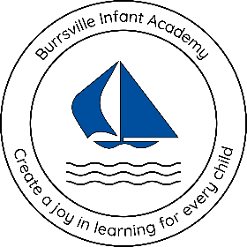
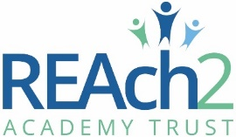

Burrsville Infant Academy

Enhanced Provision Policy
Cherry Class

Agreed and signed by:
 | Headteacher | Date:
 | Chair of governors | Date:
To be reviewed annually - last updated: 20.02.2026
Contents:

- What is an Enhanced Provision? (REAch2 Shared Understanding)
- Key Principles of Enhanced Provisions
- Enhanced Provision Expectations
- Roles and Responsibilities
- Vision Statement and Rationale
- Criteria for Admission
- Health and Safety
- Learning Environment
- Assessment and Progress
- Curriculum and Planning
- Timetable and Daily Structure
- Teaching Pedagogy
- Transitions
- Accountability: Self-Audit Tool, Trust and Internal Reviews/Monitoring

What is an Enhanced Provision? (REAch2 Shared Understanding)

An enhanced provision is a learning space outside of the mainstream classroom, for children who require a highly personalised curriculum, often through a holistic approach in a low sensory demand environment with higher adult ratios. Time in the Enhanced Provision ranges from approximately 50% to all their education.

The learning in enhanced provision is highly personalised and differentiated, often modelled on an Early Years approach to teaching and learning for children developmentally 0 – 5 years, with significant learning needs to their chronological age. An enhanced provision is highly specialised and covers a spectrum of provision types:
- Blended mainstream and Enhanced Provision curriculum
- Majority Enhanced Provision curriculum with some mainstream provision
- Full time Enhanced Provision modelling a specialist setting

This type of provision would only be suitable for a very small number of children across the Trust, and not all schools would need this type of provision. The mainstream classroom with adapted and differentiated learning should always be tried first and no assumptions should be made about a child joining your school.

Key Principles of Enhanced Provisions
To ensure Enhanced Provisions across REAch2 are of the highest standard for our most vulnerable learners, we have developed a set of key principles and expectations that all schools must meet.

Our principles:
- Inclusive and inspirational vision and rationale for the Enhanced Provision.
- Robust admissions criteria and evidence to support decisions for children.
- Learning environments are welcoming, functional, conducive to and celebrate learning.
- Nurturing staff with specialist training and continuous professional learning.
- Clear, consistent routines and structure of the day.
- Accurate assessments with robust processes for assessing and evidencing progress through targets and the assess, plan, do, review cycle (ADPR – Graduated Approach).
- Ambitious and holistic curriculum preparing children for their next stage of learning and adulthood. Focusing on developing and securing foundational skills.
- Parent partnerships are strong and focus on collaboration.
- Class teachers maintain responsibility for the attainment and progress of children within the Enhanced Provision.
- An ambitious, educational pathway for each child ensuring they are ready for their next stage of education, including robust transitions.
- All children have time with their peers in mainstream, appropriate to their needs, with aspirations to increase over time.
- Ensure all children have access to, adapted, whole school extra-curricular opportunities and enrichment activities.
- Regular internal and trust reviews of the Enhanced Provision to ensure high standards and outcomes for every child.

Enhanced Provision Expectations

Burrsville Infant Academy has high expectations for our Enhanced Provision:
- The Enhanced Provision must have high expectations for the children with no ceilings to their learning.
- The provision must be child centred, focused on individual targets in collaboration with specialists such as speech therapists and occupational therapists, to provide comprehensive support, including parents/carers' voice (wishes and feelings for their child).
- The curriculum must be broad and balanced with a holistic approach.
- There must be a clear and consistent structure to the day.
- The children in the enhanced provision must have a peer group where they are of a similar stage and experiences. They may also spend times during the day with their chronological peer group.
- Children in the provision must have the same extracurricular, enrichment and wider school opportunities as all children. These opportunities may need to be highly adapted to meet their needs. They must be part of 11 before 11 initiatives.
- The children’s needs must be considered to allow the provision to be fully inclusive. This could be by being communication friendly (see appendix A), use individual sensory profiles to ensure the room caters for their needs, ensuring the room meets children’s physical developmental needs and the children’s triggers and strengths are thought of when planning and preparing their timetable, curriculum and environment.
- Teachers and support staff must receive ongoing specialised training to support for the diverse needs of children in their care. This ensures that they can provide a higher level of expertise and care, fostering a supportive and understanding environment.
- The provision must be clearly timetabled for each individual child, including when they are able to access their mainstream classroom and peers (where appropriate and increasing over time).
- The children must have access to an outside area, if this is at playtimes with their peers or a separate space to use throughout the day.
- Class teachers must remain accountable for all children in their class’s learning, assessments and progress.
- The Enhanced Provision must be overseen by a qualified teacher and ideally children taught by a qualified teacher or, if not possible, a Higher-Level Teaching Assistant with specific training to meet the needs of the children.
- Teachers should use a variety of teaching methods tailored to the learning styles and abilities of each child. This may include; intensive interactive approaches, multisensory instruction, differentiated learning activities, and adaptive technologies to support learning.
- The provision should be equipped with specialised resources and provisions designed to support various SEN needs and/or disabilities. This includes assistive technology, sensory equipment, and adaptive learning materials.

Roles and Responsibilities:
At Burrsville Infant Academy a variety of adults work together to support children with special educational needs and disabilities. Each role has distinct responsibilities, but collaboration is key to ensuring children receive the best possible care and education.

Headteacher
Oversees the entire school, including the Enhanced Provision. Ensuring:
- A safe, inclusive, and effective learning environments with high quality inclusive teaching for all. Access to whole school opportunities and enrichment.
- Know what provisions the children require to remove their barriers to learning.
- Monitor and ensure provisions are place for children, including statutory EHCP outcomes and section F provision.
- Ensure children are progressing from their starting points and progress is evidenced.
- Enabling continuous professional learning for staff.

SENCO
Coordinates support for children with SEND:
- Oversees the Enhanced Provisions.
- Oversight of SEND support plans and EHCPS.
- Support the development of long-term curriculums, planning, assessment and evidencing progress.
- Liaise and coordinate external agencies.
- Ensure the high quality of the Enhanced Provision through monitoring.
- Enabling professional learning for staff to ensure they have the skills and knowledge to support the children’s needs.

Room leaders / Class teachers:
Responsible for the day-to-day teaching and learning of the Enhanced Provision:
- Plan, deliver and review SEND support plans (IEPs – APDR process) and EHCPs tailored to each child.
- Develop long term curriculums and short-term planning.
- Deliver daily teaching following the curriculum and provide provisions and adaptive/differentiated strategies to remove children’s barriers to learning.
- Accurately and regularly assess children, evidencing their progress.
- Collaborate with class teachers, external professionals, SENCo, leadership team, teaching assistants, and families to support each child’s holistic development.
- Class teachers are responsible and accountable for the overall progress and development of the children in their class (even if they are not leading the everyday teaching of the child within the Enhanced Provision) including where children access support from teaching assistants or specialist staff.

Learning Support Assistants:
Supporting teaching and provision with specialised training:
- Provide one-on-one or small group support.
- Assist with classroom management and help implement children’s SEND support plans and EHCPs.
- Support children with personal care needs, such as feeding or toileting, if required.
- Monitor and report on child’s progress to their class teacher and room lead.

Parental involvement:
Parental engagement in special education promotes positive child outcomes, parent-school relationships and a collaborative approach are crucial to meeting the child’s needs:
- Parents or carers should be fully involved in decisions about their child’s support and what they want them to achieve.
- Work closely with teachers, SENCOs, and external agencies to share insights about their child’s strengths, challenges, and progress.
- Attend parent-teacher meetings, reviews, and school events.
- Support the implementation of strategies at home that are used in school.

Working with Local Authorities
- Advice and support should be sought for individual children from external agencies available in the local area.
- Attendance at local area networking.
- Fully engage is working together with the Local Authority to support SEND children and their families, especially for statutory processes.
- Form networks with local specialist schools and schools with SEND resources base or Enhanced Provisions to support continuous improvement of your Enhanced Provision.

Vision Statement and Rationale
Rationale for Cherry Class:
Cherry Class has been created as a specialist provision within Burrsville Infant Academy to meet the needs of pupils with the highest levels of Special Educational Needs—children who cannot access a mainstream classroom without significant adaptations. Some require a bespoke and highly personalised curriculum, low-stimulating learning environments, or targeted interventions far beyond what can be delivered in their mainstream class. This provision mirrors the structure and support of a specialist setting, ensuring that children awaiting specialist school placements receive appropriate, meaningful support immediately.
The provision has been established in response to the growing SEND needs within mainstream schools, recognising that not all children can be effectively supported in a standard classroom environment. Cherry Class embodies the school’s core values—resilience, kindness, respect, aspire and engage—and focuses on each child’s strengths, helping them build confidence and achieve their full potential. It also allows pupils to learn alongside peers who share similar experiences, creating a supportive and understanding community.
Cherry Class offers a flexible model: for some children, it provides a temporary, nurturing space that helps them develop the skills needed to return to their mainstream classroom full-time; for others, it functions as a shared placement to support gradual inclusion. For a small number, Cherry Class serves as their full-time educational base, ensuring they can successfully begin their academic journey while waiting for the most appropriate long-term provision.

Vision for Cherry Class:
Our vision is to empower every child through highly personalised and adapted curriculum and targeted interventions that support their development in the areas most meaningful and essential to them. We are committed to working closely on individual goals—such as communication, toileting, social interaction, emotional regulation, and independence—ensuring that each child is given the tools and guidance they need to flourish.
We strive to create an environment where children can engage with learning in a setting that truly fits their needs, offering a calm, nurturing space that mirrors the approaches and structure of a specialist setting. This ensures consistency and security, particularly for those awaiting a specialist school placement, allowing them to access appropriate support without delay.
Our provision is dedicated to enabling children to experience success, build confidence, and connect with learning at a pace and stage that is right for them. Wherever possible, we work gradually and sensitively to rebuild their time within their mainstream classroom, strengthening their sense of belonging and supporting their inclusion within the wider school community.
Above all, our vision is to ensure that every child feels valued, understood, and equipped to reach their fullest potential—academically, socially, and emotionally.

Criteria for Admission

The possible need for a child to access the Enhanced Provision should follow sustained period of meaningful and purposeful high quality inclusive teaching and interventions to address the child’s SEND needs, using an Assess, Plan. Do and Review (ADPR) cycle in the mainstream classroom. A child may then be considered for the Enhanced Provision using the specified criteria below.

The decision for a child to be admitted into the Enhanced Provision must, as a minimum, include the Headteacher, SENCO, the child’s class teacher, with the child (if appropriate) and their parents. The room leader should also be included if applicable.

There must be a clear plan for each child in writing including the reasons for the decision for a child to be admitted to the school’s Enhanced Provision based on facts and evidence. A plan for the child’s long term educational pathway should also be completed.

Final placement decisions are subject to parental agreement. Parents should be involved throughout the process as per the Code of Practice, Graduated Response.

When a place in the Enhanced Provision maybe suitable (multiple aspects to be met):
- Will have an Education Health and Care Plan (EHCP) or in the processes of gaining one.
- Meet criteria for a specialist school, e.g. Significant needs in one or more of the Broad Areas of Need, which cannot be met through adaptive teaching or reasonable adjustments.
- Struggle with self-regulation due to significant sensory or communication difficulties (identified through assessments, e.g. Speech Link (scoring <50, SaLT Articulation Screener, NELI, Sensory Profiling).
- Highly anxious and experiencing extreme levels of emotional based school avoidance or escalations in behaviour communication, resulting in a serious risk to their safety and the safety of others (EBSA - When ‘Let’s Talk, We Miss You’ has been tried with no success).
- Limited language (non and pre-verbal) and require high levels of intervention and adult support to develop their communication including alternative communication strategies (visuals, signing, Objects of Reference, core boards, etc.).
- Found the demands of a school setting extremely challenging and who significantly struggle to learn in their mainstream class environment (assessed through the Six Core Strengths).
- Find social interactions extremely difficult without high levels of adult support.
- Limited or no understanding of their safety and higher adult supervision is required at all times.
- Cognitive ability/attainment is significantly below their chronological age, at least 50%.
- A part-time timetable or gradual integration has been unsuccessful or has had a limited impact.
- Discussions with parents have highlighted the needs, with an enhanced provision being agreed as in the child’s best interests by all involved.

When a place in the Enhanced Provision is this not suitable:
- To replace quality inclusive teaching and adaptive teaching within the mainstream classroom setting.
- As a replacement for unmet needs that are communicated through behaviours or the child’s emotions.
- To remove responsibility of the children’s learning and progress from their class teacher.
- For children who are able to work in their classroom with increased adult support or access highly adapted/differentiated learning.
- Children in Reception (unless agreed with the SEND or EYFS Central Team).
- For a child joining the school who has not tried their mainstream classroom with adapted, high quality inclusive teaching and increased adult support (unless agreed with the SEND or EYFS Central Team).
- Discussions with parents have highlighted barriers which can be met with additional support or referrals whilst remaining in their mainstream classroom.
- Discussions with parents have raised concerns that the enhanced provision is not suitable or in the child’s best interest and this is agreed by all involved.

What exit arrangements:
- Regular assessments and observations show that the child no longer requires the level of support provided in the Enhanced Provision.
- There has been a successful period of integration and sustained progress in the mainstream classroom environment, monitoring through the weekly reviewed reintegration timetable.
- The decision-making needs to be collaborative involving teachers, SENCO, parents, and external professionals.
- The placement of the child must be discussed and considered during their termly targeted (SEND One Plans) and annual reviews (if applicable) which would evidence the above.

Children requiring an Enhanced Provision longer term:
If a child has been in the enhanced provision for over 12 months with little to no success in being able to attend any of their mainstream class activities, then we will need to evaluate the long-term plan for the child:
- Are they needing a specialist setting/resource-based setting?
- What are the parents' wishes?
- Will they manage in a junior mainstream school? Does their long-term educational pathway need reconsidering?
- Has enough evidence/support been gathered, do any other professionals need to be involved?
- Is a review/emergency review needed of their EHCP? (if applicable)
- Is the child managing more time in the classroom than in the provision?

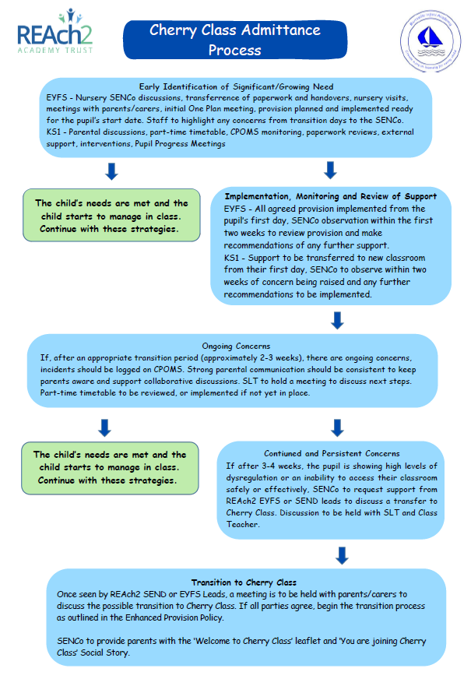

Health and Safety

Ratios including staffing model and qualifications:
We have a ratio of 1:3. Both LSAs have a strong background in supporting children, especially those with SEND. The provision is also overseen by Mrs Wheeler (SENCo), who is responsible for planning the adapted curriculum, supporting with One Planning and reviewing progress.

Accessibility:
The Enhanced Provision is accessible due to a ramp to the entrance, disabled toilet access and double handled doors to prevent absconding. Please see Burrsville Infant Academy’s Accessibility Plan for more details.

Intimate Care
Intimate Care Plans are to be created for each child to meet their specific and individual needs. This may include, toileting, deep pressure, sensory massage, etc. This must then be agreed and signed by parents/carers.

The Intimate Care Plan clearly outlines the specific intimate care required for each pupil, identifies the staff members responsible for delivering this care, and details any additional adaptations needed, including considerations for school trips. It also records any medication and how to administer this, daily care routines, and staff training requirements necessary to ensure the pupil is supported safely and effectively. Further information can be found in the Academy’s Intimate Care Policy

Emergency Procedures
Every child within the Enhanced Provision will have a PEEP (Personal Emergency Evacuation Plan). This will be developed with staff and parents. Every member of staff within the provision must know the plan for every child. Plans should be available within the room to access in an emergency.

Emergency evacuation and lock down procedures should be practice with the staff and children in the provision as per the whole school calendar.

Emergency Evacuation Procedure:
Please see Burrsville Infant Academy’s Emergency Evacuation Policy.

Lock Down Procedure:
Please see Burrsville Infant Academy’s Lockdown Policy for more information.

Learning Environment

The learning environment within the Enhanced Provision at Burrsville Infant Academy will include:
- A space within the school that is fully accessible and can accommodate the needs of the children.
- A environment that is inviting and conducive to learning. Using calming colours and minimal decorations to avoid overstimulation, whilst also reflecting the school ethos ensuring an feeling of inclusion.
- Functional areas and displays, such visual schedules, reading corners, phonics, role play areas can be simple but invoke curiosity and exploration.
- The space should be adaptable to different activities and needs.
- A space for direct teaching and access to an interactive whiteboard.
- Furniture that can be easily rearranged helps in creating a versatile learning environment.
- A sensory/calm room that is easily accessible for regulation and sensory diets.
- An emotional regulation area for children to reflect and restore.
- A messy play area, clearly marked on the floor for messy/wet play.
- Use of the children’s sensory profile and a classroom audit to adapt the room to meet their needs where possible.
- Access to outside learning opportunities.

Assessment and Progress

Assessment Systems
Assessments for children with special educational needs are crucial for understanding and supporting the unique needs of children. Assessments help educators, parents, and specialists to evaluate a child's abilities, identify specific challenges, and design tailored interventions. Assessments help in pinpointing a child's academic, social, emotional, physical abilities and communication needs. This information is essential for creating effective learning plans, environments and instructional strategies.

Within the Enhanced Provision at Burrsville Infant Academy the following assessments are used, dependent on the needs of the child and their developmental stage:
- The Engagement Model
- REAch2 Smaller Steps
- Development Matters
- Pre-Key Stage Standards (where appropriate)
- The National Curriculum
- Speech Link
- NELI
- Fine and Gross Motor (Gym Trail)
- Six Core Strengths

All assessments for the children within the Enhanced Provision will, as a minimum, follow the whole school assessment calendar and will be recorded using the whole school assessment systems.

Evidencing Progress
Every child within the Enhanced Provision will have their progress evidence using the following, as appropriate to their need and stage of development:
- Topic books
- Tapestry observations with photos, captions and observations
- Steps of progress made using the REAch2 Smaller Steps Assessments (reviewed and assessed half-termly)
- Progress towards targets on their One Plans and EHCP annual reviews
- Workbooks

SEND Support Plans (APDR Process – One Plans)
All children with SEND have plan with targets, actions and reviews following the graduate response, APDR process. All children within the Enhanced Provision at Burrsville Infant Academy will also have a One Plan breaking down their long term EHCP aims and outcomes into manageable, SMART targets.

Annual Reviews
Every child with an EHCP will have a yearly annual and 6 monthly for children under 5 years. Annual reviews will include:
- SENCo, Enhanced Provision key adult (where possible), parents and any professionals working with the child from the local authority/local health care.
- Assessment and progress information.
- Any new medical or professional advice/reports.
- Review of outcomes and aims in the child’s EHCP.
- Setting new interim targets for the coming year and where appropriate, agreeing new outcomes.
- Reviewing the special educational provision made for the child or young person to ensure it is being effective in ensuring access to teaching and learning and good progress (section F).
- Reviewing the health and social care provision made for the child.
- Considering the continuing appropriateness of the EHC plan in the light of the child or young person’s progress during the previous year or changed circumstances and whether changes are required including any changes to outcomes, enhanced provision, change of educational establishment or whether the EHC plan should be discontinued.

Curriculum and Planning

The curriculum within the Enhanced Provision is designed to be broad and balanced, meet the diverse needs of the children and aligning with the national curriculum/statutory frameworks for the development stage and learning needs of each child.

The Enhanced Provision’s curriculum is sequential with long-term, medium-term, and short-term planning. Planning is adapted to meet the unique needs of each child within the provision.

The curriculum in Burrsville Infant Academy’s Enhanced Provision is topic based, driven by key texts and individual children’s assessments and targets to ensure a highly personalised approach. The curriculum within Cherry Class is rooted in the REAch2 EYFS Curriculum, mirroring key texts, but is carefully adapted to meet the unique learning profiles of pupils with high levels of SEND. The learning environment replicates the EYFS provision, including the use of carefully selected Tier 1 and Tier 2 vocabulary to develop children’s foundational language and skills. It is designed and overseen by Mrs Wheeler (SENCo) and Miss Pargin (Deputy Head/EYFS Lead), who bring extensive experience in planning and delivering personalised and specialist curricula within specialist school environments. Cherry Class is currently in the first year of its curriculum development, with a long-term aim of establishing a three-year rolling programme to ensure curriculum coverage across EYFS and Key Stage 1. This structure will ensure that pupils are consistently exposed to a broad range of skills, learning opportunities, and experiences without unnecessary repetition and further gap widening.

Each term’s learning is shaped through detailed medium-term planning, outlining key content and texts from the Burrsville Infants Reading Spine, events, and opportunities for enrichment. This is further broken down into weekly planning, which is resourced and differentiated by Mrs Wheeler and Miss Pargin to ensure activities are accessible, meaningful, and appropriately matched to individual needs. Alongside curriculum planning, there is an extensive programme of targeted interventions aligned with the four broad areas of need. These include SEMH sessions using Burrsville Infant’s adopted resource, The Colour Monster, and the Six Core Strengths to support emotional development, as well as structured communication sessions focusing on foundational social and communication skills. Through this layered and responsive approach, the curriculum enables every pupil to access learning in a way that is relevant, engaging, and aligned with their developmental pathway.

Timetable and Daily Structure

Routines support children to understand what is expected of them in specific environments and situations. Well established routines help to reduce a child’s anxiety as they can be confident in knowing what will happen next, how people around them will behave and what they will need to do.

The timetable for the Enhanced Provision has been developed to include:
- A calm, consistent and settled morning transition into school.
- A broad and balanced curriculum covering all areas for the Early Years Curriculum or National Curriculum subjects (dependant on developmental stage of child).
- Every child must have daily phonics, maths, writing and reading appropriate to their development. Focusing on developing foundational skills.
- Where appropriate, children having time in their mainstream classroom with their mainstream peers.
- Consistent morning routine to help children transition into the school day after phonics. This includes our morning ‘hello’, looking at our emotions, numbers, the weather and day of the week. This also includes a review of the day.
- Structured learning activities with links to each child’s Smaller Steps. These activities can include continuous/enhanced provisions, hands-on learning, sensory activities, intensive interactions and individual or small group direct teaching or intervention.
- Specific/individualised interventions which are targeted to their EHCP outcomes and/or SEND Support Plan targets.
- Regular breaks and sensory activities are scheduled to help children manage their sensory needs and stay focused. This can include quiet time, sensory rooms, or outdoor play.
- Lunch breaks are a balance of social interaction with peers outside or more structured play. This is an opportunity for children to be with their mainstream peers.
- A calm, consistent and settled afternoon transition from school, with time adjusted to support parent-teacher handovers and a quieter exit.

Our Enhanced Provision’s Daily Timetable:
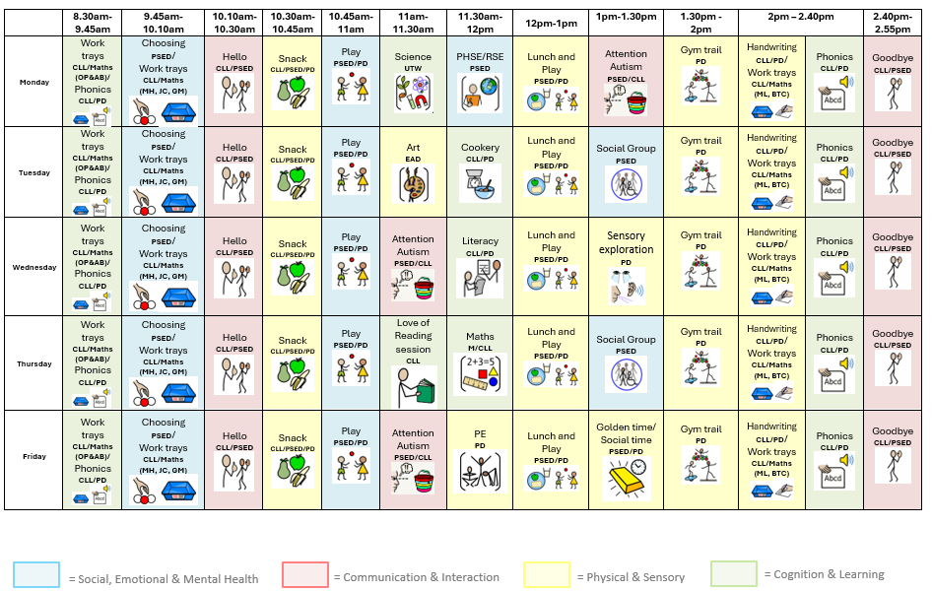

Teaching Pedagogy

At Burrsville Infant Academy we have developed a clear, evidence informed, teaching pedagogy for the Enhanced Provision to meet the needs of the children developmentally and remove their barriers to learning.

How are children taught in the Enhanced Provision:
The teaching pedagogy in Cherry Class is firmly child-centred, with every aspect of learning tailored to the individual needs, strengths and developmental stage of each pupil. Following a ‘stage not age’ approach, teaching is designed to meet pupils exactly where they are, enabling them to make meaningful progress through approaches that feel natural, engaging and successful for them—such as play-based learning, sensory exploration and active learning opportunities. In Cherry Class, we fit the environment to the child, not the child to the environment.

Staff celebrate every achievement, however small, recognising that progress may look different for each child. All learning activities are designed to be as accessible as possible, drawing on tools such as core boards, sensory resources, Widgit symbols and Makaton to remove barriers and support understanding.

Teaching in Cherry Class supports the holistic development of every pupil, with practice aligned to all four broad areas of need. Staff recognise that communication, cognition, sensory regulation and social-emotional development are deeply interconnected, and that progress in one area supports growth in all others. The classroom environment is communication-rich, with visual timetables, now-and-next boards, lanyard visuals and consistent use of Makaton and Widgit throughout the day.

Strong, secure relationships between staff and pupils are central to the pedagogy; practitioners take time to understand each child deeply and advocate for their needs. To ensure strong links with their mainstream class, the children’s class teachers visit Cherry Class weekly, actively engaging in activities to support their learning. All staff engage in reflective practice, continually reviewing provision, evaluating outcomes and refining approaches to ensure they are consistently improving and providing the highest possible standard of support for the children in Cherry Class.

Transitions

Transition support is crucial for children with SEND and must be a key consideration when assessing and reviewing their progress and next steps.

Transition into the provision:
When a child joins the provision the following steps are taken to ensure a successful transition:
- Prior to starting visits teachers and safe adults share information about the child including strengths, weaknesses and triggers.
- Adults in Cherry Class make an active effort to play and engage with new pupils, building strong, secure connections from the start.
- Children are supported to read a ‘Joining Cherry Class’ social story, with a copy sent home for families to embed this.
- The child will have sessions in Cherry Class with a trusted adult to support familiarity and security.
- Continuity of Support: We ensure that all necessary support and resources are in place before the transition, including provision that makes them feel welcome and included (e.g. their picture on their peg).
- Strong communication links between SLT, SENCo and all professionals involved in their learning.

Transition to mainstream classroom:
When a child increases their time in mainstream to re-integrate the follow steps are taken to ensure success:
- Time increased through weekly reviews of the reintegration timetable
- Cherry staff to support the child in class initially, withdrawing support as appropriate
- Class LSAs to spend time with the child, building strong relationships in a positive way
- Strong communication between Cherry Class and the class team
- Check-ins with the child to discuss their feelings
- Ensure that the child’s provision is mirrored in their mainstream classroom for a seamless transition
- Social stories where appropriate

Transition to a new provision/school:
When a child transitions to a new setting the follow actions are completed to ensure a successful transition:
- Meetings to be held with current SENCo, new SENCo, parents, child (where appropriate) and class teams
- SENCo to share relevant paperwork to ensure a seamless transition of support, providing time for the new setting to implement this prior to their start date
- Create a transition passport, including the pupil’s voice
- Transition days – additional to others
- Social stories from the new team, where appropriate
- Once school settings have been allocated, groups of pupils moving together to be facilitated to allow discussions and peer interactions

Accountability: Self-Audit Tool, Trust and Internal Reviews/Monitoring

Enhanced Provisions evolve overtime, as do the needs of children. The Enhanced Provision at Burrsville Infant Academy will have regular reviews, as a minimum of yearly. Regular reviews ensure that best practice is consistently applied and is effective in achieving the intended outcomes, ensuring that policies remain compliant with current legal requirements and the provision continues to be purposeful and impactful.

The REAch2 SEND Central Team will review every new provision within the first two terms and then there will be a review at least every two years thereafter.

