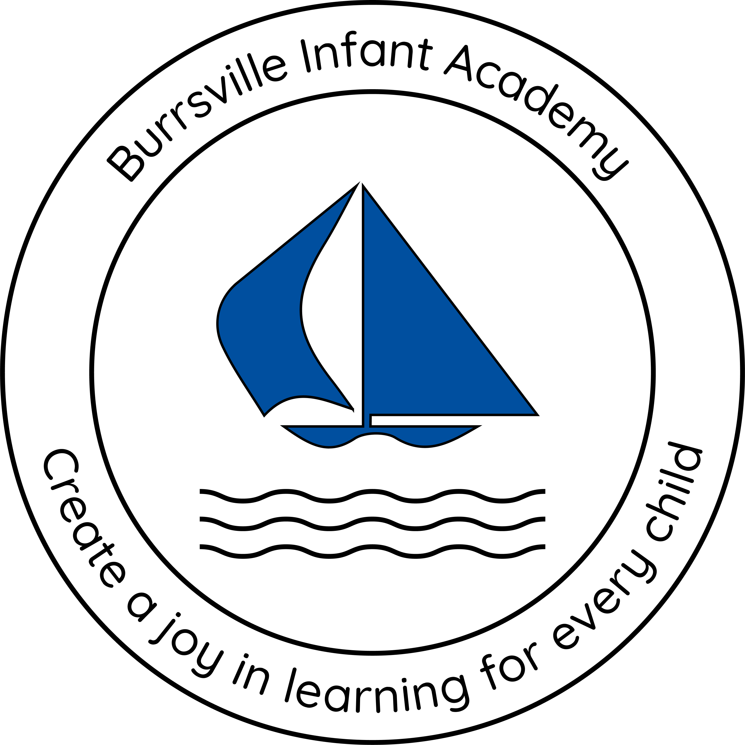
Implementation
- History is taught through cross-curricular projects, designed to give children opportunities to develop archaeological techniques, historical concepts, knowledge, skills, vocabulary and the attributes of a historian.
- As children progress through the school, they revisit appropriately sequenced historical knowledge, skills and vocabulary so that they are built on year-by-year and across projects. This ensures children are given opportunities to achieve depth in their learning.
- Each project gives pupils opportunities to develop their skills of enquiry, and the necessary skills to argue their point of view, by exploring historical concepts through undertaking high-quality research. Historical investigations are designed to encourage pupils to ask perceptive questions, think critically, weigh evidence, sift and debate arguments and develop perspective and judgement about the past in a philosophical and open manner.
- Historical ideas and findings will be confidently communicated in a variety of creative ways to a range of audiences.
- Children are provided with a variety of opportunities for historical learning inside and outside the classroom, including visiting experts, educational visits, fieldwork and residentials, all, of which, enhance the historical learning experience.
- Appropriate curriculum-themed home learning tasks will be given out, which children complete with adults at home.

Intent
At Burrsville, we aim to instil in pupils a curiosity and fascination about history that will remain with them for the rest of their lives. They will have a good understanding of chronology through learning about Britain from the Stone Age to the present day as well a realisation of the rich history in their locality. They will have an appreciation of how Britain has influenced and been influenced by the wider world and recognise how national and global historical events, and individuals in history, have shaped Britain and the world. Pupils will develop a deep knowledge of the characteristics of ancient civilisations through studying the achievements and the rise and fall of the earliest empires.
At Burrsville, pupils will become skilled historians who can think analytically about history, recognise how contrasting interpretations of the past have been formed from a range of sources and interrogate how historical evidence is used to make assertions about the past. They will develop the skills of refining questions, making connections, drawing contrasts and analysing trends over time. Pupils will be able to articulate their understanding of historical concepts such as continuity, change, causes and consequences, similarities, differences and historical significance, through imaginative forms of communication.

History
Curriculum


Impact

Our History curriculum is planned so that pupils have a good understanding of historical concepts, knowledge, skills and vocabulary that ensures they achieve age related attainment at the end of each Key Stage.

Upon completion of each project, teachers will assess children against the progression of historical concepts, knowledge and skills document.

