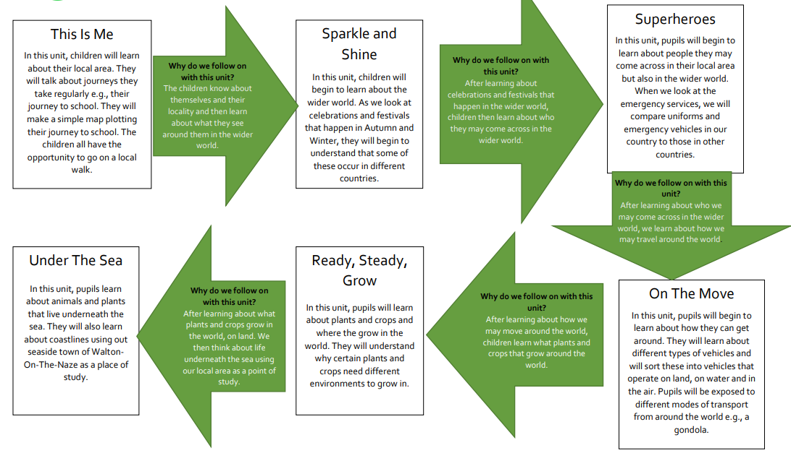
Curriculum Road Map EYFS
Curriculum Road Map Year 1
Why do we follow on with this unit?
To develop knowledge of places of interest in the United Kingdom and identify famous landmarks and different types of buildings.

London’s Calling

Suggested person: Christopher Wren

Spring
In this unit, we will focus on London as an area of study. Children will investigate and compare London’s geographical human and physical features. They will use their knowledge of reading maps, using positional and directional language, to find, identify and explore the many landmarks and different types of buildings across the city. In conjunction with this, they will examine the influence Christopher Wren had on London’s architecture.

Home Sweet Home

Suggested person: Boris Johnson

Autumn
In this unit, we will introduce the children to simple maps, road maps and aerial images of their local area. This will enable them to identify the human and physical features of the surrounding region. Children will name and locate the countries, capitals and surrounding seas that make up the United Kingdom and examine each country’s defining characteristics.

What skills will we continue to build upon?
Using photographs and maps to find and identify physical and human geographical features and give directions using locational and directional language.

Why do we follow on with this unit?
To consolidates place knowledge of countries and cities within the UK. To understand seasonal weather and compare weather patterns in different locations and UK countries.

Whirling Weather

Key Person: Robert Fitzroy

Summer
This unit will introduce the links between seasons and weather patterns. Children will investigate how weather changes, based on location, and be able to identify different types of weather and their symbols. The children will learn about Robert Fitzroy, a key person in meteorology, and the impact he made on weather reporting.

What skills will we continue to build upon?
Using the language of simple compass directions (North, East, South and West), to describe the location of continents, features and routes on a map.

Curriculum Road Map Year 2

Why do we follow on with this unit?
Learning extends outwards from the UK and Europe to introduce the other continents and the world’s hot and cold climatic regions.

Wonderful World

Spring

The children identify on maps and learn the names of the seven continents. They understand that they consist of many countries. World population statistics are introduced, and children present this information. They learn about the equator and Poles, locate them on maps, atlases and globes and identify countries in hot and cold regions. They apply knowledge of the compass directions NSEW. They conclude the unit by naming and locating the world’s oceans, understanding that they cover the majority of the earth’s surface.

You’re in Europe

Autumn

This unit will further examine UK characteristics in more detail, expanding on weather patterns and physical and human geographical features, as well as observing the cultural differences between each country. Pupils will also explore the different countries that make up the continent of Europe, identifying their human and physical features.

What skills will we continue to build upon?
Further development of mapping skills using maps, atlases and globes to identify the continents and oceans and the precise use of compass points to describe the cardinal positions of continents in relation to each other and to create routes to follow.

Coming to Kenya
Suggested person: life of a Kenyan child
Summer –

This unit compares the local area in UK, and its lifestyle, to a region in Kenya and a Kenyan child’s way of life. Pupils will be able to identify and draw comparisons between the physical and human characteristics across the two countries in relation to their continents. They will develop a deeper understanding of how our location in the world dramatically impacts our way of life but also how certain aspects of culture, weather and transport can connect us.

Why do we follow on with this unit?
To develop a deeper understanding of the differences between continents such as weather, transport, physical and human features and how location in the world impacts how we live our lives.

What skills will we continue to build upon?
Using OS maps, keys and fieldwork to follow and in turn devise maps with keys created out of their own symbols.

Curriculum Road Map Year 3
Why do we follow on with this unit?
To develop an understanding of how the continent of Europe, including the UK, was formed over millions of years and of the earth’s formation - what lies beneath the land that we live on.

What’s Beneath Our Feet?

Suggested person: Vulcan (Roman God of fire)

Spring -

This unit will explore what is under our feet, starting at the earth’s core and working our way up to the tectonic plates. We will identify how volcanoes are formed and the process by which they erupt. Additionally, we will consider the impact they have on human settlements and land use.

Counties, Countries and Cities to see!

Autumn –

In this unit, we explore counties, regions and borders looking in depth at the characteristics of various counties in the UK. This leads onto an understanding of the make-up of Europe and its countries and cities, with a focus on key concepts such as population and tourism.

What skills will we continue to build upon?
Using atlases, globes and maps to pinpoint tectonic plate locations and plot tectonic plate movement. Developing compass work through learning the eight points of a compass and carrying out four-figure grid reference exercises.

Why do we follow on with this unit?
Further examination of extreme geographical processes that affect the continents and their populations. To make further connections between physical and human geography.

Quakes and Shakes

Summer –

In this unit, children learn more about two forces that shape our earth: earthquakes and tsunamis. They learn the characteristics of each one: how they are formed, their main features and the destruction they can wreak upon the land as well as animal and human populations. Case studies are explored, and the children learn about the physical and human aspects of these events. They undertake cross-curricular work such as DT and science, making a seismograph to take measurements, and a ‘mini’ tidal wave to observe the powerful effects of water. Finally, the children learn how affected places try to recover from these catastrophes and plan.

What skills will we continue to build upon?
Children will apply geographical understanding to real-life events and identify and interpret evidence of how human and physical aspects of geography are often intertwined. They will use digital/computer mapping (Google Earth) to locate countries and describe features studied and undertake a practical task to reinforce their understanding of large-scale geographical processes.

Curriculum Road Map Year 4
Moving Mountains

Suggested focus(s): The Adi Tribe

Autumn –

This unit will identify and locate mountainous regions around the world. The children will learn how different mountains are formed, be able to recognise the role of contour lines on an OS map to indicate steepness and develop a better understanding of the flora, fauna and animals which have adapted to live in this region. They will learn about the effect of mountains in the water cycle and the impact seasonal tourism has on a region.

Spectacular Spain

Spring

This unit will focus on Barcelona in Spain. It will compare its physical and human features, climate and culture with the local area that pupils live in within the UK. In addition, pupils will learn about trade links with the United Kingdom and explore the topography of Europe in order to choose the best location to set up an orange farm.

Why do we follow on with this unit?
To develop a deeper understanding of how the topography of the land influences agriculture and human settlement.

What skills will we continue to build upon?
Using 8 points of the compass, aerial, OS and topographical maps to identify physical and human geographical features. Analysing data and creating charts and graphs to present their findings.

Why do we follow on with this unit?
To examine how different geographical regions and climatic zones can dramatically impact land use.

The Amazing Amazon

Summer –

The children identify the northern and southern hemispheres and Tropics of Cancer and Capricorn using globes and atlases and come to understand their significance as climate zones. The countries of South America are introduced, before focusing on the Amazon rainforest. Pupils create graphs to compare rainfall and temperature between the Amazon and the UK. They learn about the importance of this habitat and the threats it continues to face from competing pressures. Finally, the children find out about current initiatives that aim to protect the rainforest from devastation.

-

What skills will we continue to build upon?
Research and analyse geographical data, diagrams and aerial photographs. Create computer-generated graphs to represent their findings and orally present their interpretations and conclusions.

Curriculum Road Map Year 5

Why do we follow on with this unit?
To build on the knowledge that physical features (coastal areas in addition to rivers) affect human activity within a region or place and can be the reason why people settle in particular areas.
.

Cool Coasts

Spring

The children build on their knowledge of locating and identifying continents using maps and atlases. They identify some well-known coastlines and see that they have differences in features and climate. They will study how beaches are formed in relation to the rest of the coastline and examine the processes of weathering and erosion that shape these areas. In human geography, they learn why tourism is important to many coastal towns and look at how the nature of employment and population is linked to coastal regions.

Rivers

Autumn

In this unit we will investigate the different formations, functions and purposes of rivers. We will locate major rivers across the world and compare the use of the Mississippi and Severn rivers. Additionally, we will explore why humans naturally settled by rivers and develop our use of grid references.

What skills will we continue to build upon?
Consolidate skills of using maps, atlases, globes and digital/computer mapping (Google Earth), in greater detail, to locate countries and describe the physical and human geographical features studied.

Why do we follow on with this unit?
To further explore how physical geography, geographical location and weather influence human activity and land use (such as farming), commercialism and trade.

Field to Fork

Summer

This unit develops children’s understanding of climate zones and how they impact on global farming. Children learn about how latitude lines help locate climate zones and longitude lines indicate time zones. Children investigate different types of farming and produce and the journey of food from source to plate. They discover how fair trade positively impacts farm workers and gain an understanding of the challenge’s farmers face.

What skills will we continue to build upon?
To use longitude and latitude to locate countries, temperate zones and time zones. Field work in order to collect data, analyse and present findings.

Curriculum Road Map Year 6
Green Planet

Autumn

In this unit we will explore the various biomes around the world and identify their distinctive characteristics, including climates, vegetation and natural animals. Additionally, we will use six-figure grid references to locate places on a map.

Why do we follow on with this unit?
To extend knowledge of biomes by examining the largest biome of all – the marine biome. To deepen understanding of how species (in this case marine) adapt to their environment.

Blue Planet
Suggested person: Dame Ellen Macarthur
Spring –
Children will recognise the characteristics of the world’s oceans and learn to identify the different layers that make up an ocean. They will learn how different marine species adapt to their environments and investigate a marine area and the impact that tourism has on it. Pupils will identify the influence of overfishing on a UK working fishing village and learn about the dangers that plastic represents to marine life and other creatures that have the ocean as their habitat.

What skills will we continue to build upon?
Use world maps to identify and label continents, oceans, seas, rivers, countries, the equator and lines of latitude and longitude in order to recognise the characteristics of the world’s oceans.

Overheating Planet
Suggested person: Greta Thunberg

Summer
The children learn the causes and effects of climate change, specifically looking at the consumption of fossil fuels and their contribution to the ‘Greenhouse Effect’. They understand that fossil fuel industries have dwindled in the UK but were once very important. They learn about coal mining in South Wales as a case study and understand that fossil fuel industries are still booming in other countries. They look at the demand for other products and the impact on our planet, such as the clearance of forests in Borneo for palm oil production. They finish by considering new initiatives to develop more sustainable sources of energy and find out about the influence that Greta Thunberg has had.

Why do we follow on with this unit?
To consider how the worldwide issue of climate change impacts on land and marine biomes.

What skills will we continue to build upon?
Interpreting, making connections and presenting their findings in relation to geographical data and information sources.

