White Rose Long Term Plan EYFS
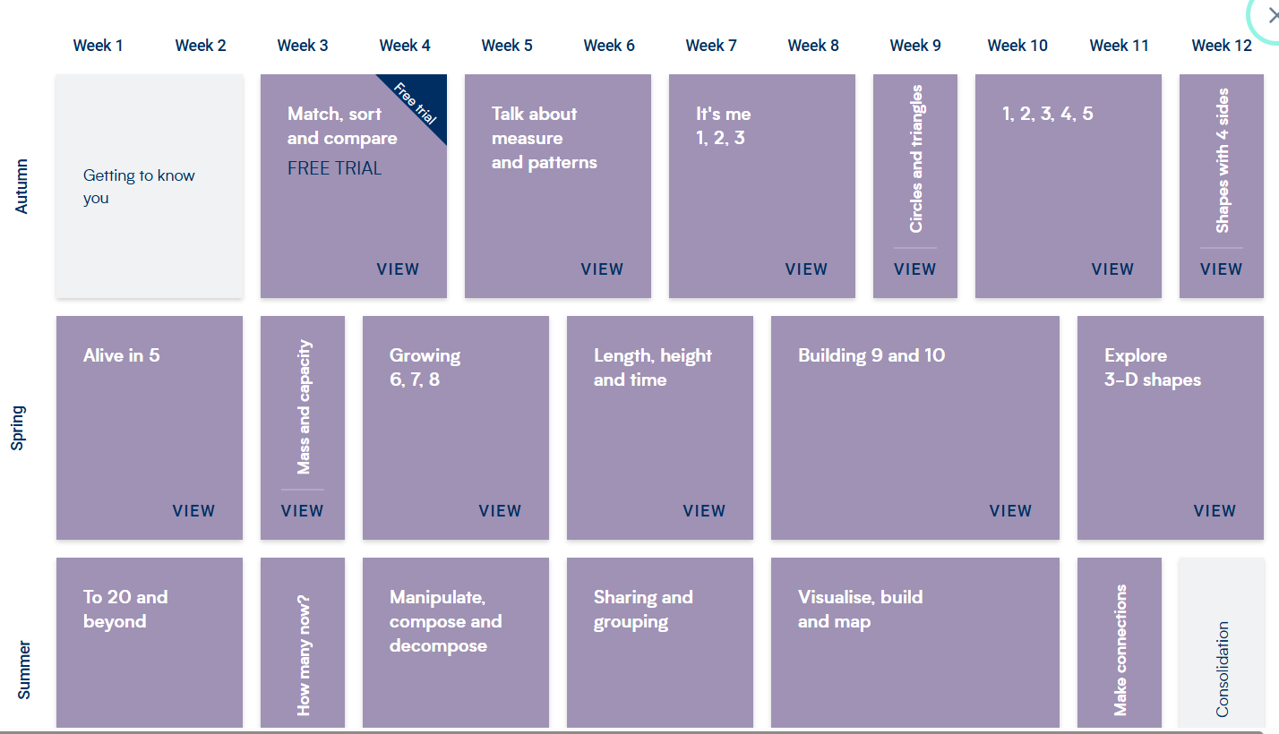

White Rose Long Term Plan Year 1
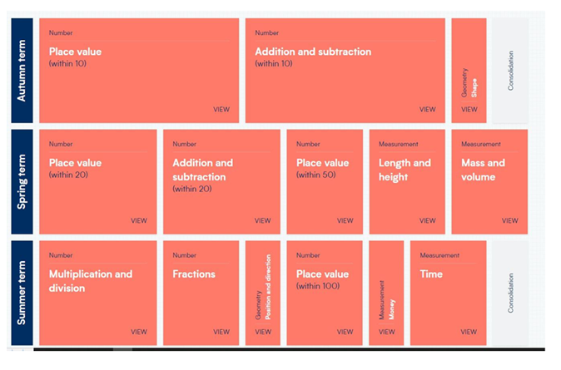
White Rose Long Term Plan Year 2


